**PART 1**

**Mid-Term Task Part I 1**. Host a static website on Blob Storage: build and deploy a static Hello World website to Azure Storage. 2. Verify that the default web page has the Hello World! page. 3. Provide the steps and results.

1.Create an Azure Storage account:

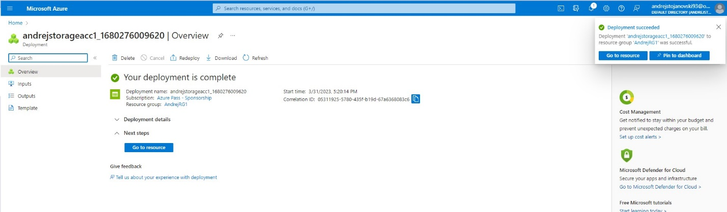

2.Enable static website hosting:

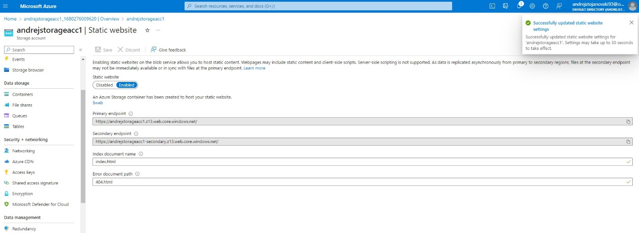

3.Build your "Hello World" website

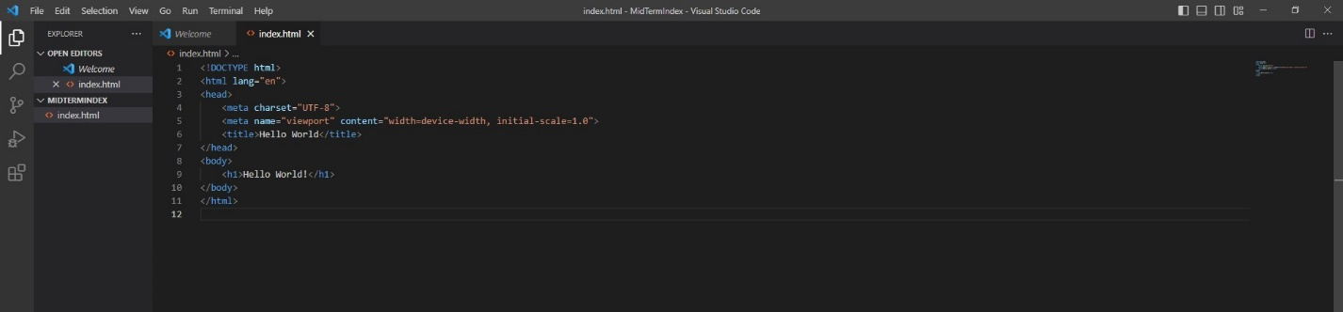

4.Deploy your "Hello World" website to Azure Storage:

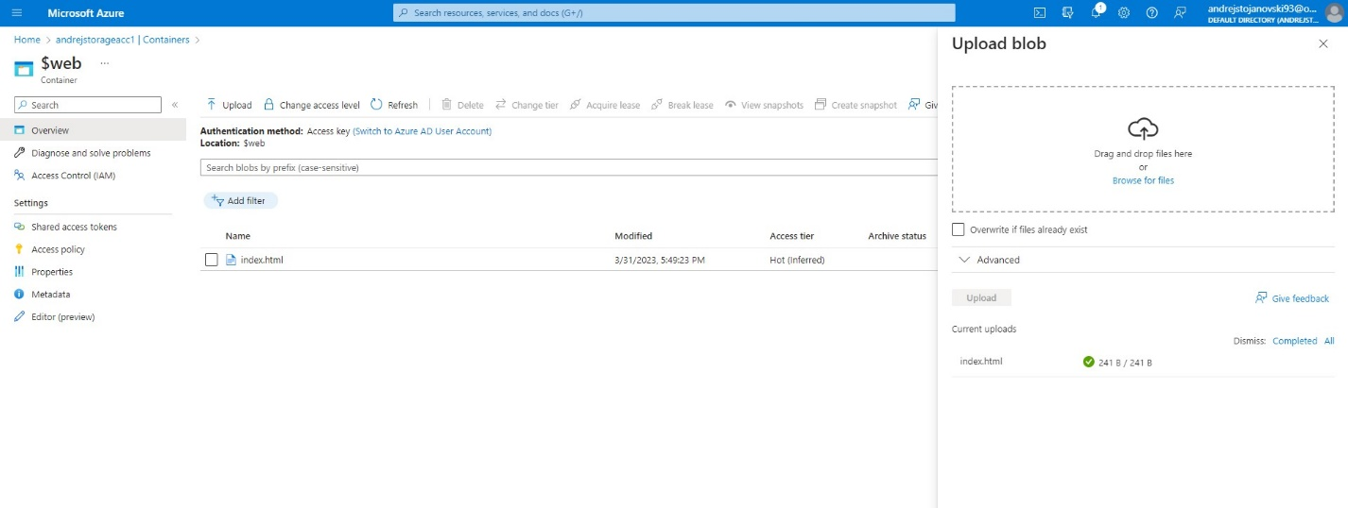

5.Verify that the default web page has the "Hello World!" page:

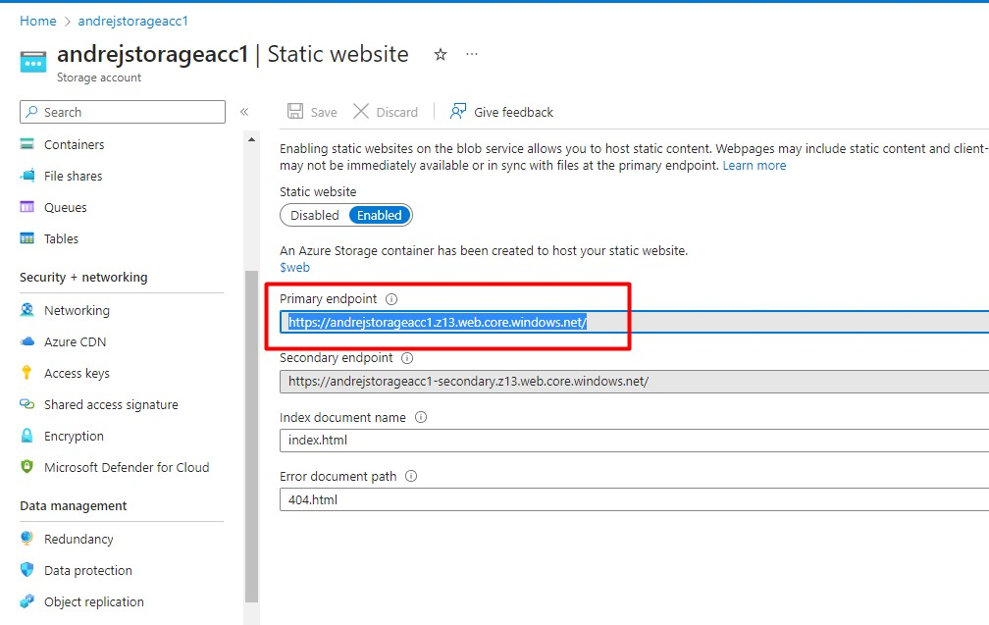

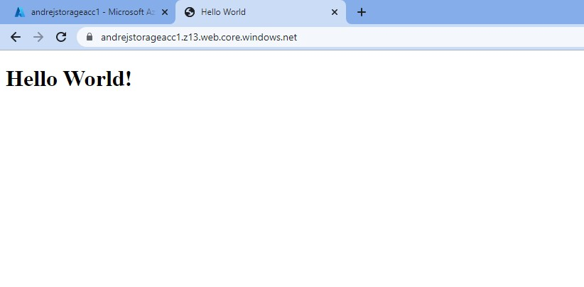

**PART 2**

1. Create a Virtual Network:

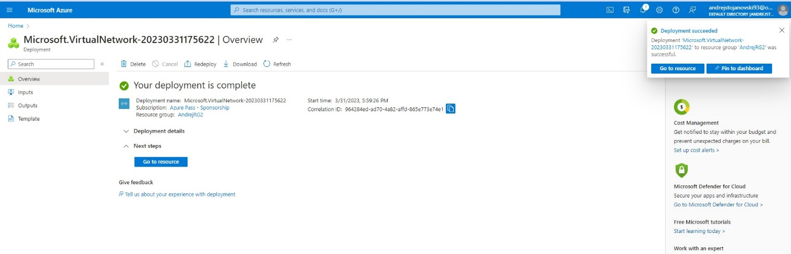

1. Modify the network security group:

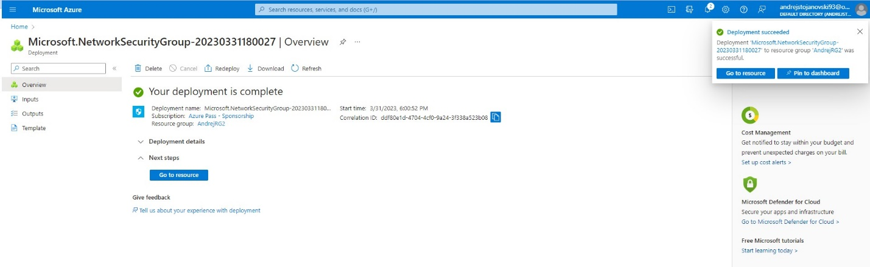

1. Create a rule that allows SSH (port 22) from your local machine's IP address.

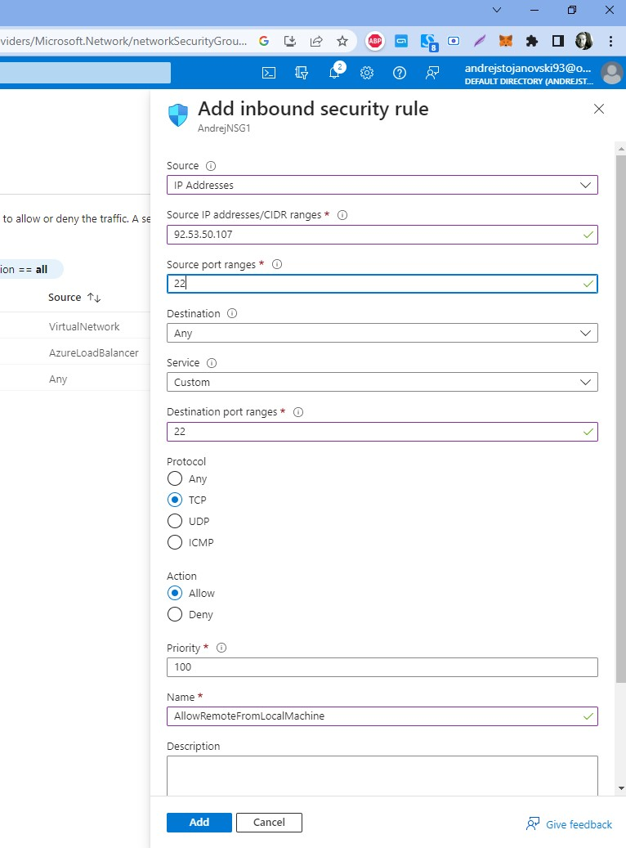

1. Create another rule that allows HTTP (port 80) from your local machine's IP address.

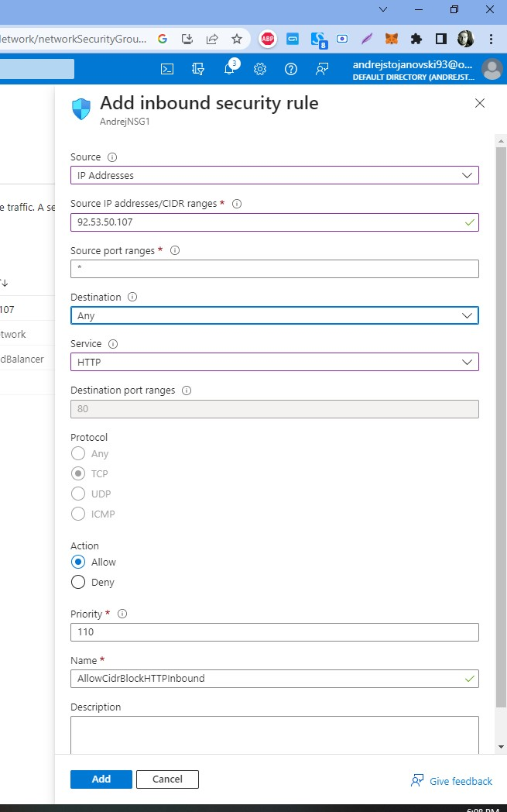

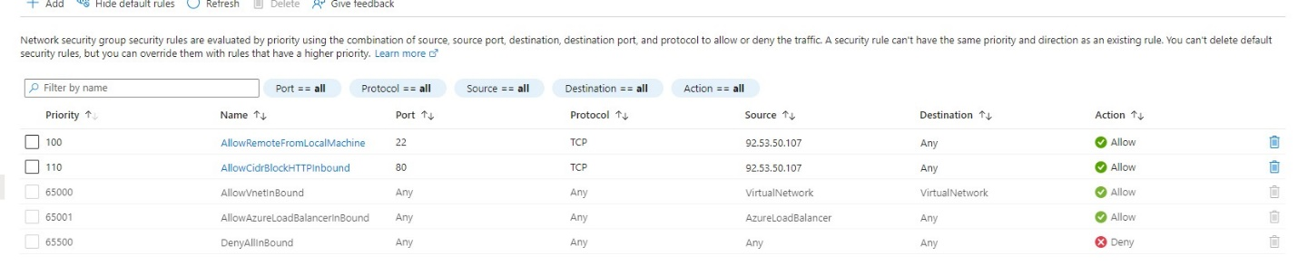

1. Create a Linux Virtual Machine:

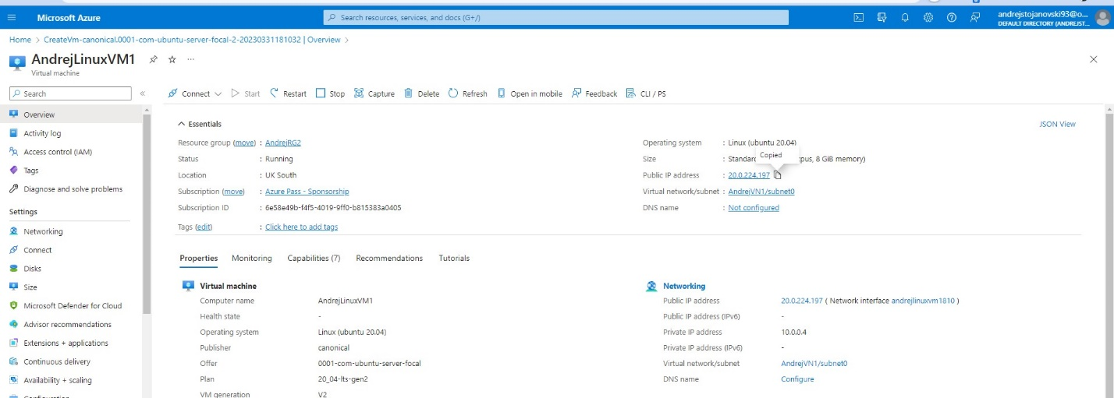

1. Connect to the VM:

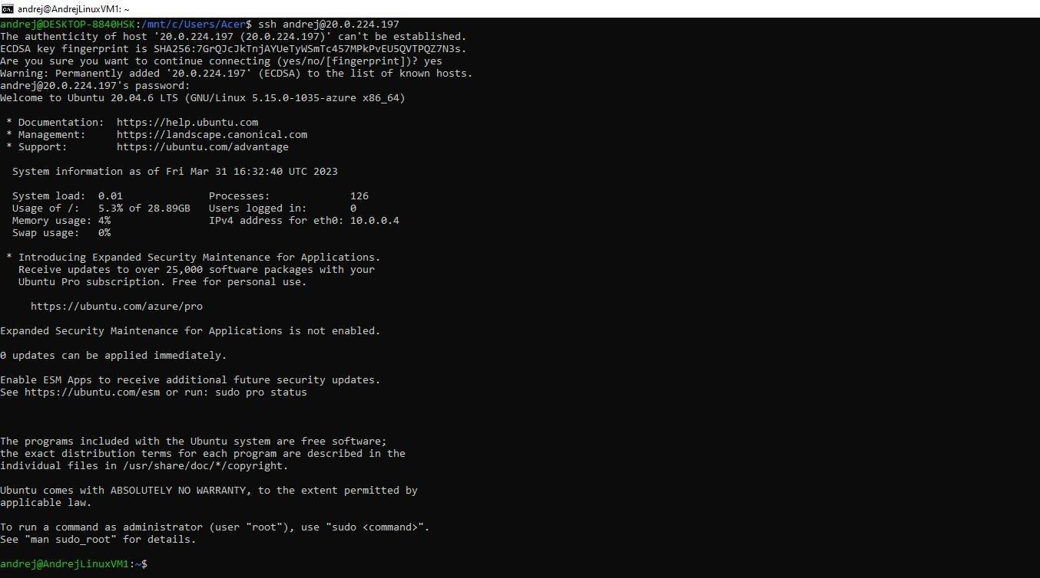

1. Install Apache Web Server:

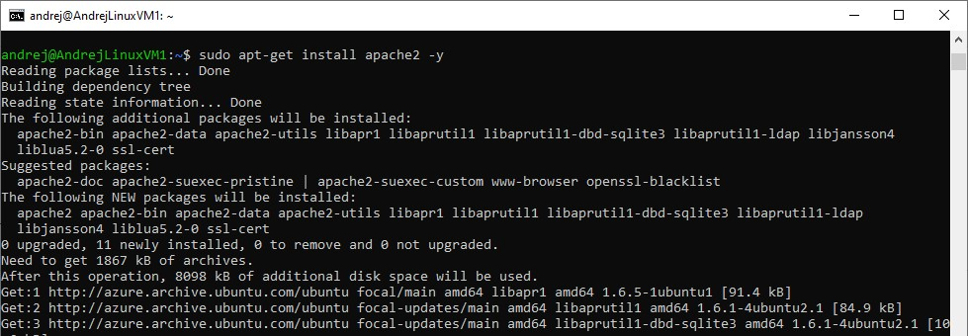

1. Check the status of Apache Web Serv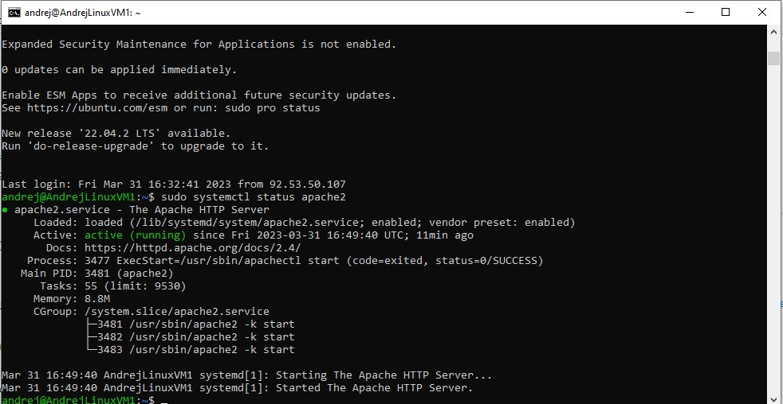

9.Connect to the public IP of the Linux VM, without the change in HTML page (default)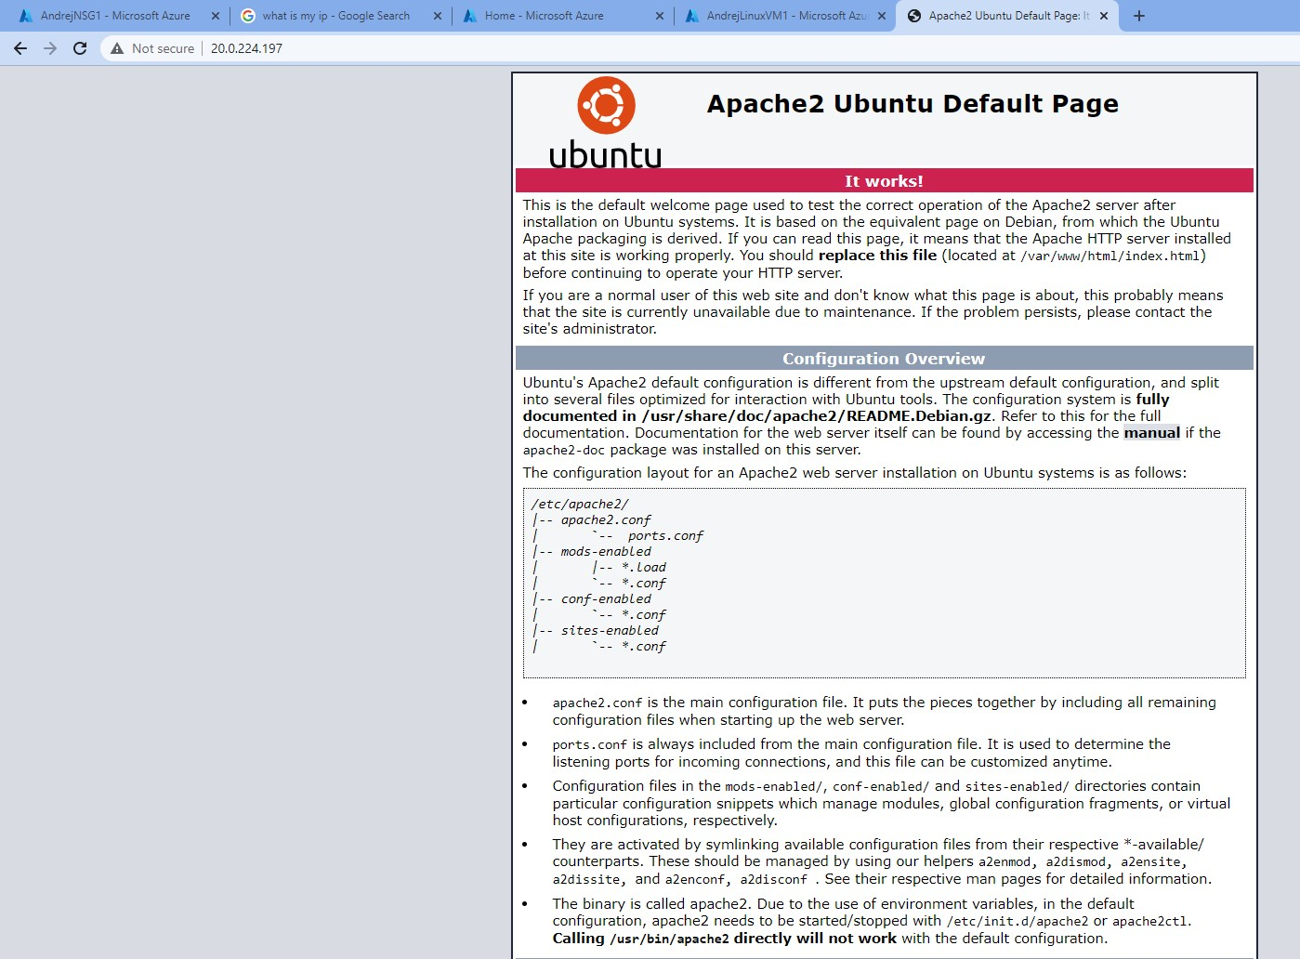

10.Change the HTML page to Hello World!

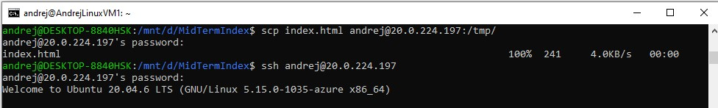

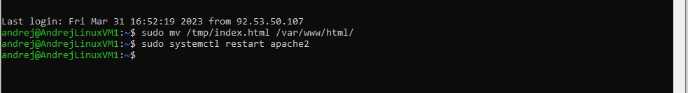

11. Reload the page after changing the html page on apache web server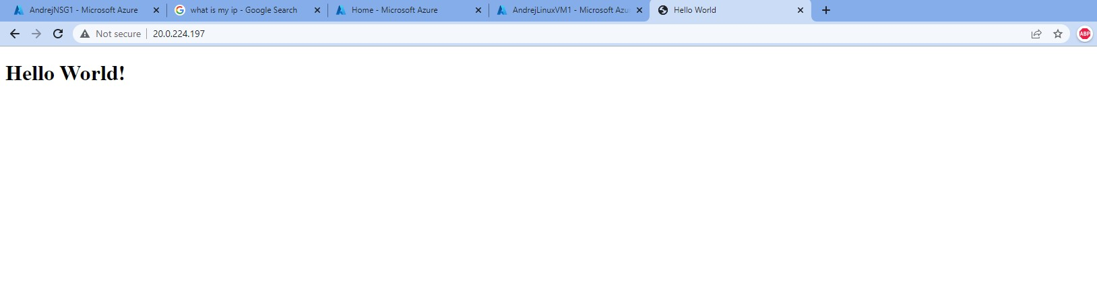

12. From cellphone

